Strong interactions between scientists and stakeholders are critical for incorporation and use of new scientific information into decision-making, as end-users must perceive the information to be salient, credible, and legitimate. Stakeholders relevant to the ABoVE field campaign include local community members, Indigenous organizations and governments, and other decision-makers such as land and wildlife managers at state, territorial, and federal agencies.

Early engagement with stakeholders, sustained attention, and appropriate acknowledgement are key components of achieving these goals. There are many resources available on guidelines for working with communities, co-production of knowledge, incorporating Indigenous Knowledge, etc. Here we highlight just a few.

- Understanding the history and legal status/sovereignty of Indigenous peoples

The history and legal status of Indigenous peoples differs both within and between the US and Canada and are the result of many historical processes. Take some time to learn about the history of the Indigenous peoples you are working with, and learn about their sovereignty and governance. One place to begin is Native Land: https://native-land.ca/

Many ABoVE researchers, generally hailing from the US, may especially not be aware of the status, rights, and history of Indigenous peoples in Canada. Important things to note:

  - Not all tribes in Canada are First Nations. Additionally, the term “Native American” is generally only used in the US. The best way to refer people/tribes broadly is to use the term Indigenous (note that it should be capitalized).

  - In 2015, the Truth and Reconciliation Commission of Canada identified 94 Calls to Action to further reconciliation between Canadians and Indigenous peoples. To learn more:

https://www.rcaanc-cirnac.gc.ca/eng/1400782178444/1529183710887
https://nctr.ca/map.php

- Best practices for conducting research with Northern communities

The Arctic Research Commission of the US (ARCUS) has put together a list of resources for conducting research with Northern communities, including specific sections on working with Alaskan and Canadian communities: https://www.arcus.org/resources/northern-communities

- Resources for Research Co-Design and Knowledge Co-Production

Thinking about differing levels of engagement between stakeholders and researchers:
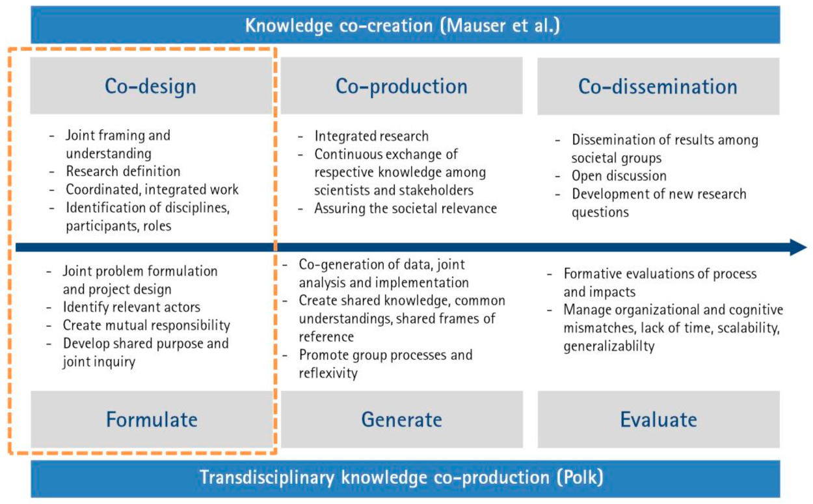
Henze, Jennifer, Barbara Schröter, and Christian Albert. 2018. “Knowing Me, Knowing You—Capturing Different Knowledge Systems for River Landscape Planning and Governance.” Water 10 (7): 934. https://doi.org/10.3390/w10070934.

A recent special issue in Nature “looks at the promise and the pitfalls of research coproduction for the societies, stakeholders and scientists now working shoulder to shoulder.” https://www.nature.com/collections/nnqkvntryl. It includes examples, metrics for valuing co-production, and commentary.

Discussion Questions

- Who are the relevant stakeholders for your research, both known and hypothesized?
- What are ways that you can and/or are planning to engage with relevant communities?
- Are there other ABoVE projects who have the same or similar stakeholders? Can you work together on engagement to minimize “research fatigue” for these communities?

